**Journal**

**Preliminary Day**

Researched project ideas and landed upon the idea of working on Windows Forms to make my game and <https://www.thenewboston.com> was my resource.

**Day 1**

Watched 4 videos from the website and did the following:

* Made a Windows Form Application
* Adjusted the Form so it included features I needed. I.e. docked tool box, message box
* Created 3 group boxes to display the word guessed, hangman and letters already chosen
* Created 2 buttons one for submit letter and another to submit word
* Wrote Journal for Day 1

**Day 2**

Watched 2 videos and did the following:

* Wrote code for the panel and how to draw using the pen
* Learned how computer uses coordinate system just like math to locate text boxes;(i.e. there are x and y coordinate and each have a unique number in the computer)
* Learned how to name the game
* Wrote Journal for Day 2

**Day 3**

Watched 3 videos and did the following:

* Used enumeration to store all the body parts
* Learned how to draw Head,Left Eye,Right Eye,Mouth and Right Arm
* Learned how to draw the hangpost for the hangman to hang on
* Wrote Journal for Day 3

**Day 4**

Watched 3 videos and did the following:

* Added a textbox for missed letters
* Learned how to draw Left_Arm,Body,Right_Leg and Left_Leg
* Learned how to use internet library and added website to get random words from
* Wrote Journal for Day 4
* Worked on the Definition report

**Day 5**

Watched 2 videos and did the following:

* Experienced many errors because my program to didn’t work properly since when user entered an input it didn’t disappear when user press enter and I fixed that using Thomas’s help(since in the video they did not explain how to use the “submit letter” button) so then with his help I learned how to use the events in the properties
* The program did not work at all even after that because I clicked on random labels and didn’t define their function
* Wrote Journal for Day 5
* Edited the Definition report from Day 4

**Day 6**

Watched 1 video and did the following:

* Wrote Journal for Day 6
* Made error message boxes for showing users input if something other than a letter is used
* Made message boxes for instructions
* Made message boxes for incorrect input

**Day 7**

Watched 1 video and did the following:

* Used labels to display any missed or incorrect letter
* Used labels to display the word length
* Wrote Journal for Day 7
* Wrote my analysis report

**Day 8**

* Wrote Journal for Day 8
* Edited all my code was facing some errors with formatting and the letters did not display because I did not have them in the right function
* The word they had to guess appeared when they opened the program because my code displayed the word they had to guess right at the beginning because it was in the wrong function

**Hangman Game with a twist**

Hangman with a twist is not just any random hangman game but instead it comes with a twist! This game is made in Windows Form which makes it all the more riveting! The object of the game is to guess all the letters in the game before the hangman is made.

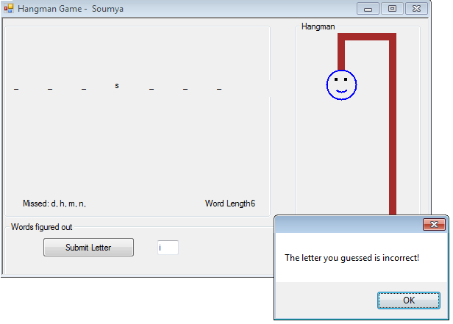

The user will start by entering a letter each time and if they guessed an incorrect letter; a message box(as shown above) will inform them on their mistake. When the message box displays, users can also see another body part displayed on their screen and there is also a “Missed” label that shows the user which letters were incorrect so that they do not repeat their missed letters again. Once the user enters eight incorrect entries; the game is over! Then they have to restart the game from scratch.

**Analysis Report**

* Variables used to store user input and to store random word
* Website used to get random words from
* For loop used to see if user input matches word
* Windows Form Application used to make game
* Used labels for labelling text boxes
* Used lists to store labels
* Used random word generator to generate random words from the website
* Message boxes used to display instructions, error messages and incorrect letters
* Used graphics in Windows Form to draw body parts of hangman for each incorrect letter
* Instructions are displayed in the beginning of the game
* Correct letter appear on the underscores so they know how close they are to the word
* Incorrect letters appear in the missed label so that same letters aren’t repeated again
* Different methods used to clean up the code as not to inundate the user
* Used enumeration to store all the body parts
* Error messages show if user input is something other than a letter and prevents anything other than letter input